 | Health Equity Data Analysis
4/30/2018 | Southwest Health and Human Services Final Report: Lincoln County Rural Poverty

Health Equity Data Analysis

Final Report: Lincoln County Rural Poverty

Executive Summary

Contents
Executive Summary 1
Definition of Health Equity 1
HEDA Purpose and Steps 1
Connections between Social Determinants of Health and Health Outcomes 1
Identifying the Population 2
Difference in Health Data 2
Differences: Social and Economic Factors 2
Differences in Poverty and Income 2
Differences in Education 2
Differences in Healthy Eating and Physical Activity Opportunities 2
Causes of the Unjust Conditions 2
Methodology 2
Next steps 2
Acknowledgement 2
Appendices 2

Definition of Health Equity
According to the World health Organization, “Equity is the absence of avoidable or remediable differences among groups of people, whether those groups are defined socially, economically, demographically, or geographically.” Common characteristics in groups that experience health inequity are the lack of political, social or economic power. (1) Generally, the lack of power in our region is seen in earnings for women, rural vs urban earnings, populations of color, and access to health, dental and mental health care to name a few.
Multiple factors affect health including the dynamic between people and their environments. When assessing a community’s health, it is important to consider the interconnected factors of where and how an individual lives, where they work, socialize, and learn. Lifestyle behaviors and genetic disposition affect a person’s health but so does more upstream factors including employment status, availability to transportation, and quality of housing. The Social Determinants of Health Conceptual Framework address the distribution of wellness and illness among a population- its patterns, origins, and implications.
In 2010, the World Health Organization published a report on how to influence social determinants of health in order reduce health inequities. In the figure below structural mechanisms in the socioeconomic and political context of policies, governance and culture give rise to socioeconomic position where people are stratified by how much money they have, the color of their skin, education attainment, gender, occupation, age, and other factors. These factors shape the intermediary determinants, which include where people are in social hierarchies. Social status determines exposure level and how vulnerable a person is to experiencing a negative health conditions. Once a person becomes ill, you will see that impact feedback through the system influencing structural determinants. (2)
Commission on Social Determinants of Health Conceptual Framework
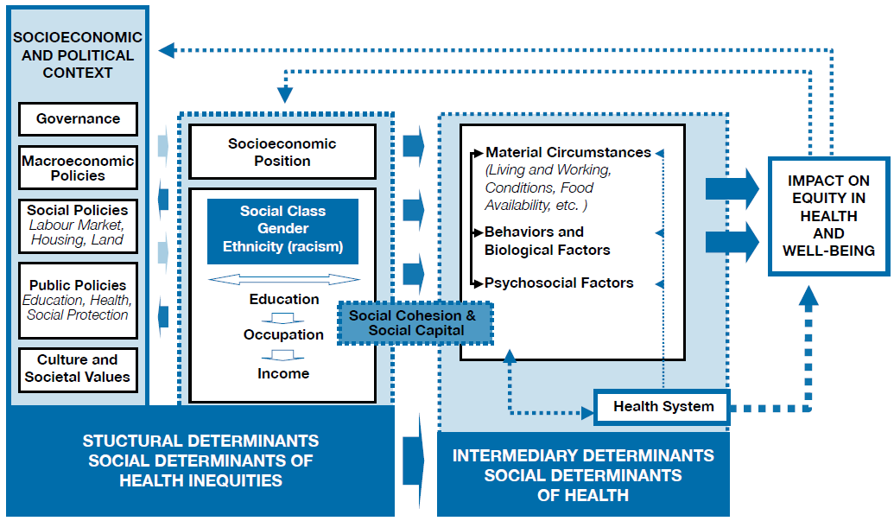
When groups face serious social, economic, and environmental disadvantages, such as structural racism and a widespread lack of economic and educational opportunities, health inequities are the result. A health disparity is a population-based difference in health outcomes (ex: women have more breast cancer than men). A health inequity is a health disparity based in inequitable, socially determined circumstances (ex: American Indians have higher rates of diabetes due to the disruption of their way of life and replacement of traditional foods with unhealthy commodity). Because health inequities have social causes, change is possible.
Addressing health inequities through policy, systems, and environmental (PSE) changes are different from the traditional way of administering programs. Traditionally, Public Health programs are implemented to change behavior in individuals and community. However, there is a growing emphasis on addressing societal factors that affect behavior. Those would be through addressing PSE. Policy strategies may be a law, ordinance or rule (both formal and informal). System strategies involve changes to the economic, social, or physical environment.
The work of Southwest Health and Human Services (SWHHS) aims to be a catalyst in the movement upstream to address causes and improve environments in our communities, neighborhoods, schools, and work places with the ultimate goal of health equity for all individuals of Southwest Minnesota.

Health Equity Data Analysis Purpose and Steps
Health Equity Data Analysis (HEDA) purpose is to tease out of various data sets that have more than 30 respondents the factors that are influencing social determinant of health. In SWHHS counties, finding 30 respondents in survey data can be difficult when looking at persons of color. Once these factors are known, policy, systems and environments can be examined to determine what upstream course of action can be taken to help remediate the health inequity that is being seen in the data.
The five-step process to conduct a HEDA is as follows:
A. Connection Step: Connect health outcomes to conditions that create health
B. Population Step: Identifying the population likely to experience health inequities
C. Differences Step: Looking for population‐based differences in health outcomes
D. Conditions Step: Linking social and economic conditions to differences in health outcomes
E. Causes Step: Describe and recognize the causes of these unjust conditions

Connections between Social Determinants of Health and Health Outcomes
Conceptual Model of how Living in Rural Areas Impacts Health
Boston Public Health Commission; Graphical Adaptation (3)

Identifying the Population
Southwest Health and Human Services serves a largely rural area with rolling farmland in Lincoln, Lyon, Murray, Pipestone, Redwood, and Rock. This primarily agricultural area produces corn, soybeans, winter wheat, hogs, feeder cattle, dairy products, and in Pipestone County, lambs and sheep. The current population estimate as of 2015 in the six-county area is 74,332. (4) The largest city within the service area is Marshall with a population of 13,793. (5) Demographics for the SWHHS counties show that the population is continuing to get older. From 2000 to 2015, there was an increase of 4,571 people in the 50-69 age ranges. (6)
The population within Southwest Health and Human Services remains a high percentage of white. The region saw a shift in the distribution of populations of color from 98.6 percent white in 1990 to 92.6 percent in 2010. In 2015, the percent of white increased slightly to 93.2. (7) For Lyon and Murray Counties, this represented over a 500 percent increase; Redwood and Rock over 300 percent increase; Lincoln over 200 percent increase; and Pipestone over 150 percent increase in the populations of color. (8) In 2016-2017, three SWHHS school districts had 35.1 percent or higher minority student population; two districts had 25.1 to 35 percent of minority student population. (9)

Lincoln County
The focus of the HEDA is Lincoln County. Lincoln County was organized in 1873 and includes the cities of Lake Benton, Wilno, Tyler, Ivanhoe, Hendricks, and Arco. The citizens are Polish, Danish, Norwegian and Icelandic heritage. Ivanhoe is the home of the county seat. Lincoln County is 100 percent rural and has the dubious distinction of being the only county in Minnesota without a traffic light. The county is one of the smallest and poorest counties in Minnesota.
The population of Lincoln County as of 2015 estimate is 5,771 people with 98.32 percent of the population being White, 0.23 percent Black/African American; 0.24 percent American Indian/Alaskan Native; 0.47 percent Asian/Pacific islander and 0.75 percent Two or More Races; Hispanic Latino Ethnicity makes up 1.99 percent of the population. The population is largely older than 55 year old, with 1,469 making up the 55-79 age group and 1,253 people age 80 and older. Combined the population that is 55 years old and older makes up 48 percent of the population while in all six SWHHS counties this age group makes up 33 percent of the population.

Difference in Health Data
In spring 2015, SWHHS participated in the Southwest/South Central MN Adult Health Survey (SW/SC MN Adult Health Survey), which touched a 16 county area. The survey instrument included Behavior Risk Factor Surveillance System (BRFSS) and Statewide Health Improvement Partnership (SHIP) questions, which gave a comprehensive data set to analyze and use for the HEDA project.
This Health Equity pilot focused on the geographic area of Lincoln County due to the high percent of adults 55+, its designation by the University of MN Extension as a food desert in terms of limited food access, and the opportunity to collaborate and build new partnerships within the communities of Lincoln County to impact overall health outcomes.
When data from the SW/SC MN Adult Health Survey was pulled by age and region, Lincoln County saw higher smoking, Body Mass Index (BMI), High Blood Pressure and Cholesterol rates for ages 55+ than the region. In a close analysis of the SWHHS counties, Lincoln County had the highest percent of adults 65-75 who smoked, highest BMI% for 55-64 year olds, highest percent of adults age 55+ diagnosed with high blood pressure, and largest percent of adults 55-64 who had been diagnosed with high cholesterol. (10)
The following tables illustrate the differences noted by age categories, county, and region.
Smoking Rates
 | 55-64 | 65-74 | 75+
Lincoln | 12.5% | 17.4% | 3.2%
SWHHS | 10.6% | 10.4% | 5.0%
Obese Weight Status According to Body Mass Index
 | 55-64 | 65-74 | 75+
Lincoln | 44.9% | 43.7% | 29.0%
SWHHS | 41.6% | 42.8% | 26.9%
Have you ever been told by a doctor or other health care professional that you had HIGH BLOOD PRESSURE / HYPERTENSION?

 | 55-64 | 65-74 | 75+
Lincoln | 45.3% | 63.8% | 73.6%
SWHHS | 38.7% | 58.4% | 60.0%
Have you ever been told by a doctor or other health care professional that you had HIGH CHOLESTEROL OR TRYGLYCERIDES?
 | 55-64 | 65-74 | 75+
Lincoln | 52.1% | 52.7% | 46.3%
SWHHS | 42.6% | 50.3% | 43.6%

Causes of the Unjust Conditions
In the article Social Determinants of Health: Implications for Rural America, Dr. Ferdinand highlights the challenges of residents living in rural communities. Rural areas are more likely to have higher poverty rates than urban counties, have greater challenges in obtaining quality housing and food, have lower educational attainment, and higher social isolation. (11) Barriers to healthcare access can contribute to health disparities as well. Healthcare workforce shortages are prevalent with less than 8% of all physicians and surgeons choosing to practice in rural settings. (12). Services available in rural areas are less likely to include specialized and highly sophisticated or high-intensity care. Transportation to care can be a barrier due to long distances, poor road conditions, and the limited availability of public transportation in rural areas. (13)
According to the National Center for Health Statistics report Health, United States, 2016, nonmetropolitan (rural) residents report higher rates of multiple chronic conditions. Rural areas tend to have higher rates for many of the most prevalent chronic diseases: High cholesterol, hypertension, arthritis, depressive disorder, diabetes, chronic obstructive pulmonary disease, and heart disease. (14) As people age, their risk of having multiple chronic conditions goes up, and rural areas have more older people, as a percent of the population. (15).
This data is consistent with Lincoln County health outcomes.

Methodology
In order to better understand why Lincoln County residents 55+ experience chronic disease outcomes at higher rates than other older adults in the region, Southwest Health and Human Services Public Health staff conducted three focus groups with residents 55+ and eight key informant interviews in Lincoln County. The focus groups were held in the communities of Ivanhoe, Tyler, and Hendricks. An additional focus group was held with Lincoln County staff of Southwest Health and Human Services. Key interviews were held in the community of Lake Benton.
Focus group and key informants were asked specific questions regarding their definition of health; what helps them be healthy, the challenges to keep healthy; and suggestions how SWHHS could support health in their community. Additional questions were asked regarding physical activity, healthy eating, and tobacco use. A focus group protocol was created and approved by MDH and incentives were given to residents for participation.
FOCUS Group and Key Interview Results
Twelve questions were asked of participants, with several probing questions available to ensure adequate information was received. Once data was analyzed by Southwest Health and Human Services SHIP staff, an evaluation summary was created with themes and a list of recommendations. Please see the Lincoln County Health Equity Data Analysis Evaluation Summary to see full results.

Next steps
The next steps of this project include sharing results with participants, local policy makers, and community partners. First, with the completion of the Evaluation Summary, the results of this study will be shared with FOCUS group/Key Interview participants. This will be done through participant-indicated preference of contact (email or mail). Second, SWHHS SHIP staff will present results and recommendations of the HEDA to the Lincoln County Commissioners and to the Southwest Health and Human Services Governing Board. As policy makers, they have an opportunity to make decisions from a Health in All Policy lens. We are hopeful this will help educate lawmakers on Health Equity and its impact our region. Finally, many recommendations of the HEDA are tied to community partnerships. As we continue the work of SHIP, we will strategically seek out our Lincoln County partners to educate them on the outcomes of the HEDA and creatively identify ways we can support ongoing efforts to improve Lincoln County health outcomes for adults 55+.

Acknowledgement
The Health Equity Data Analysis report was made possible through funding from the Statewide Health Improvement Partnership (SHIP) grant, as directed by the Minnesota Department of Health. SHIP focuses on making policy, systems, and environmental change through the support of community partnerships to make all Minnesotans healthier.
SWHHS would like to acknowledge staff for their support throughout the HEDA process, as well as the local service providers and community members who helped plan and recruit members for the focus groups or Key informant interviews. Some of these individuals include: Rosanne Lasnetski, Anne Lichtsinn, Jenifer Vollmer, Beverly Vos, and Ellen VanErdewyk.
Questions or follow-up on the HEDA can be directed to:
Ann Orren, Community Public Health Supervisor
Southwest Health and Human Services
ann.orren@swmhhs.com or 507-532-1317
Jen Nelson, SHIP Coordinator
Southwest Health and Human Services
jennifer.nelson@swmhhs.com or 507-532-1243

Appendices

Lincoln County Health Equity Data Analysis Evaluation Summary1

Lincoln County Health Equity Data Analysis Evaluation Summary1

Focus group protocol- Lincoln County 2017
Focus group questions- Lincoln County 2017

Bibliography
1. World Health Orgnization. Health Systems; Equity. [Online] 2017. [Cited: August 17, 2017.] http://www.who.int/healthsystems/topics/equity/en/.
2. Solar O, Irin A. A Conceptual Framework for Action on the Social Determinants of Health. Social Determinants of Health Discussion Paper 2 (Policy and Practice). s.l. : World Health Organization, 2010. ISBN 978 92 4 150085 2.
3. Boston Public Health Commission. What is Health Equilty? [Online] [Cited: August 11, 2017.] http://www.bphc.org/whatwedo/health-equity-social-justice/what-is-health-equity/Pages/what-is-health-equity.aspx.
4. Department of Administration; Minnesota State Demographic Center. Our Estimates; Popfinder for Minnesota, Counties and Regions. [Online] April 1, 2017. [Cited: June 21, 2017.] https://mn.gov/admin/demography/data-by-topic/population-data/our-estimates/pop-finder1.jsp.
5. —. Our Estimates: PopFinder for Cities and Townships. [Online] April 1, 2017. [Cited: June 21, 2017.] https://mn.gov/admin/demography/data-by-topic/population-data/our-estimates/pop-finder2.jsp.
6. Minnesota Department of Health. 2013 Minnesota County Health Tables: Morbidity. Minnesota Center for Health Statistics. [Online] Minnesota Department of Health. [Cited: February 14, 2017.] http://www.health.state.mn.us/divs/chs/countytables/profiles2013/index.html.
7. United States Census, Population Division. American Fact Finder. Annual Estimates of the Resident Population by Sex, Race, and Hispanic Origin for the United States, States, and Counties: April 1, 2010 to July 1, 2015 PEPSR6H. [Online] June 2016. [Cited: April 27, 2017.] https://factfinder.census.gov/faces/tableservices/jsf/pages/productview.xhtml?pid=PEP_2015_PEPSR6H&prodType=table.
8. Center for Rural Policy and Development. Atlas Online. RurualMN.org. [Online] [Cited: February 16, 2017.] http://www.ruralmn.org/atlas-online/?tab=2&report=55.
9. Minnesota Department of Education. Data Reports and Analytics: Student; 2016-17 Enrollment by Ethnicity/Gender. Minnesota Department of Education Data Center. [Online] [Cited: April 11, 2017.] http://w20.educa tion.state.mn.us/MDEAnalytics/Data.jsp.
10. Wilder Research. 2015 Southwest/South Central MN Adult Health Survey. St. Paul : Wilder Research, 2015. Data Book.
11. Ferdinand, AO. Social Determinents of Health: Implications for Rural America. In: Bolin JN, Bellamy G, Ferdinand AO, et a. eds. Rural Healthy People 2020. Vol. 2. College Station, TX: The Texas A&M University Health Science Center, School of Public Health, Southwest Rural Health Research Center; 2015: 95-107.
12. National Center for Health Workforce Analysis. 2014. Distribution of U.S. Health Care Providers Residing in Rural and Urban Areas. [Online] [Cited: December 27, 2017.] https://www.ruralhealthinfo.org/pdf/rural-urban-workforce-distribution-nchwa-2014.pdf
13. Rural Health Information Hub. 2017. Healthcare Access in Rural Communities. [Online] [Cited: December 27, 2017] https://www.ruralhealthinfo.org/topics/healthcare-access
14. National Center for Health Statistics. Health, United States, 2016: With Chartbook on Long-term Trends in Health. Hyattsville, MD. 207. https://www.cdc.gov/nchs/data/hus/hus16.pdf#page=204
15. Rural Health Information Hub. 2017. Chronic Disease in Rural America. [Online] [Cited: December 28, 2018] https://www.ruralhealthinfo.org/topics/chronic-disease

